

National Apprentice and Industrial Training Authority

Diploma in Software Engineering

**M08 – Web Application Development**

&

**M09 – Mobile Application Development**

**(Semester II)**

Practical Assessment – Project Proposal

MerchMercatò E- Commerce Marketplace

Isira Dilum – DSE-A-022 - Orugodwatta

Jeth Shevan – DSE-E-001 - Orugodwatta

Minidu Ransith – DSE- 030 – Orugodwatta

Tharaka Sirinimala – DSE-G-016 – Orugodwatta

Esandi Hesara – DSE-E-001-Orugodawatta

Ministry of Skills Development, Vocational Training, Research & Innovation Division

**Table of Contents**

**Chapter 1: Introduction** 1

**1.1** **Introduction of the Organization** 1

**1.2** **Organization Structure** 1

**1.3 Current Operations in the Organization** 1

**1.4 Users and Responsibilities in the Organization** 2

**1.5 Problem Definition** 2

**1.6 Project Objectives** 2

**1.7 Proposed Solution** 3

**1.8 Chapter Summary** 3

**Chapter 2: Methodology** 4

**2.1 Introduction** 4

**2.2 Data Collection Method(s)** 4

**2.3 Software Process Model** 5

**2.4 Software Development Tools** 5

**2.5 Testing Strategies** 6

**2.6 Implementation Plan** 6

**2.7 Chapter Summary** 7

**Chapter 03: Design & Analysis** 8

**3.1 UI Design** 8

**3.1.1 Wireframes – Web** 8

**3.1.2 Wireframes- Android** 13

**3.1.3 Mockup – Web** 19

**3.1.3 Mockup – Android** 23

**3.2 ER Diagram** 27

**3.3 UML Diagram** 28

**3.4 Class Diagram** 29

**Chapter 04: References** 30

# **Chapter 1: Introduction**

## **Introduction of the Organization**

Merch Mart is a tech-enabled startup marketplace that helps artists and influencers in monetizing their creativity by selling merchandise directly to their fans. Merch Mart develops a web application based on React JS and an Android application, making it very easy for any artist to create, manage, and sell merchandise. Artists of small and medium size often have to surmount many obstacles to financial success, as most revenues tend to accrue to a few popular creators. Merch Mart tries to correct this balance with a platform that enables artists to maximize their fanbases for sustainable incomes and further engagement with audiences.

In this regard, Merch Mart ensures that both web-based and mobile applications are provided. Ensuring the applicability of both artist and fan base to varied platforms without restriction to any one preferred platform.

## **Organization Structure**

Organized to facilitate the seamless collaboration of technical, business, and marketing teams across functions, Merch Mart can develop both an Android and a web application. The company will be organized in a way that agile product development and market outreach are feasible.

Administrator

|

Artists and Influencers

|

Fans and customers

## **1.3 Current Operations in the Organization**

Operations Merch Mart focuses on the development and launch of both Android and Web applications simultaneously. Major operations include:

* **Administrator:** Total function maintenance of the application.
* **Artists & Influencers:** To ask how they want to personalize their store, future needs, and provide feedback.
* **Groupies & Consumers:** Market visits and buying.

## **1.4 Users and Responsibilities in the Organization**

Merch Mart services different types of key user groups on both the web and mobile platforms:

* **Artists/Influencers:** They will create their merchandise, manage, price, and interact with their fans. They will also make use of built-in marketing tools to promote their stuff.
* **Followers/Clients:** Browse through merchandise on the web and mobile applications and make purchases; follow favorite artists for notifications on product drops.
* **Administrators:** Keep both platforms running smoothly, ensure all transactions occur safely, and that some troubleshooting of both is done.

## **1.5 Problem Definition**

Small and medium artists barely create sustainable income for themselves within the entertainment industry because there are a very limited number of platforms that are fit for their merchandising needs. The few available ones are either too complicated, take heavy commissions, or leave all the logistics to be managed by the artist. Merch Mart solves that problem by providing a platform that gives the artist easy-to-use tools to create, manage, and sell merchandise both on the web app and the mobile app. In this way, they can engage directly with their fans while having full control over their product offerings.

## **1.6 Project Objectives**

The objectives of the project at Merch Mart are:

1. Provide a seamless cross-platform experience by creating a responsive web application using React JS, complemented by a mobile app using Java/ Kotlin. This gives artists and fans the ability to work with the platform from any device.
2. Offer real-time fan engagement via notifications and promotion tools on both platforms.
3. Integrate secure payment gateways like Hela Pay, both on the web and mobile app, to ensure that any merchandise sale made through the application is seamless and secure.
4. Advanced analytics, tracking tools for artists to deeply understand sales performance in order to maximize strategies on both platforms.

## **1.7 Proposed Solution**

Merch Mart will be developing a web and Android application to empower artists in an easy way to create and sell merchandise. Be it product creation, inventory management, sales tracking, or customer engagement, both the web and Android applications will provide the necessary tools. The React JS web application will allow users accessing the platform from desktops with a dynamic, fast interface, while the Android application will offer a mobile-friendly experience, enabling users to manage their stores and interact with fans on-the-go.

Key features include:

* **Product management tools** for uploading designs, pricing, and inventory tracking.
* **Fan engagement tools:** notify customers of product launches, special offers, and personal messages.
* **Provide a secure means of payment** by integrating a safe method of transaction with HelaPay on both platforms.
* **Real-time analytics** on the performance of an artist, including sales and engagement by their fans.

## **1.8 Chapter Summary**

It was a dual-platform approach that Merch Mart had taken to build its marketplace for artists and influencers. The organizational structure has been explained, and it must also be focused on the way this collaborative approach has been handled so far by technical, business, and marketing teams. Current operations are concurrent development of web and mobile apps, artist onboarding, and marketing campaigns. The problem definition, objectives, and proposed solution were outlined in explaining how Merch Mart is best positioned to support small and medium-sized artists in the entertainment business.

# **Chapter 2: Methodology**

## **2.1 Introduction**

The proposed React JS web application and the development of the Android app will be performed using the Agile methodology. In Agile, the iterative approach allows for the flexibility to accommodate responses to user feedback and market demand. Each sprint will be focused on the development activities regarding both the web and mobile platforms, maintaining consistency in user experience and functionality across devices.

## **2.2 Data Collection Method(s)**

The promotion of usability on both web and mobile platforms will be ensured at Merch Mart through the use of the following techniques of data collection:

* **Surveys and Interviews**: Influencers and artists will be surveyed and interviewed for capturing some points on what they experience in existing merchandise platforms. This shall serve useful feedback with respect to their preferences regarding the handling of product sales, thus informing the design and functionality of both web and mobile apps.
* **User Testing**: In the beta stage, selected artists and fans will try both platforms to give feedback on usability, performance, and feature set. Refinements can be made prior to the full launch.
* **Market Research**: Competitor analysis will also be carried out to understand the strengths and weaknesses of similar existing platforms such as Shopify and Teespring. This will help Merch Mart in offering unique features, targeting small and medium-sized artists in the entertainment industries.

## **2.3 Software Process Model**

Merch Mart will adopt the Agile SDLC approach for both the web and Android platforms. This process allows continuous feedback and iteration toward feature development and refinement based on real-world use cases.

* **Sprint 1**: **User Registration & Profile Setup**  
  This would also involve giving the ability for fans to create an account, set up a profile, and manage their preferences; this includes secure user authentication and initial setup of data storage.
* **Sprint 2: Merchandise Creation & Management**  
  With Merch Mart, artists will be able to upload designs, categorize products, and manage inventory on both platforms. Real-time updates concerning stock levels and product availability will also form part of the sprint.
* **Sprint 3: Payment Integration & Order Management**  
  Hela Pay will be integrated into the web and mobile applications for secured payment processing. Development of order tracking, notification features, and transaction history will be developed in this sprint.
* **Sprint 4: Fan Engagement Tools**  
  These will include notifications, special offers, and personal messages as a way an artist can engage their fans. Tools for engagement like these will be easily accessible on both the web and mobile platforms to enable the artist to reach out with whatever device used.

## **2.4 Software Development Tools**

The tools and technologies for both platforms would be as follows:

* **React JS**: The web application framework, being adopted since it provides great flexibility, scalability, and fast rendering.
* **Java / Kotlin**: This would be used for the development of the Android app, aiming to provide top performances for mobile phones and user experiences.
* **Firebase**: Will take care of the user authentication along with real-time management of data in the applications securely providing the account management feature to the artists and their fans, besides keeping track of sales.
* **Hela Pay API**: This is to be used for web and mobile platforms, ensuring seamless and safe payments.
* **Figma**: It ensures that UI/UX design remains intuitive and consistent on both the web and mobile interfaces.

## **2.5 Testing Strategies**

Testing of the platforms is another key concern to ensure their reliability for seamless experiences for the users.

* **Unit Testing**: The testing of individual components, such as user sign-up, merchandise management, and payment settlement systems, whether they work appropriately.
* **Integration Testing**: Integration testing will be carried on in both the platforms for smoothness in working amongst compatible components, like a catalog of merchandise with the processing of payments.
* **System Testing**: Web and Android applications have to go through real-time testing; when an artist launches his latest product, high traffic should not cause either of the applications to malfunction.
* **User Acceptance Testing (UAT)**: Artists and fans will go through UAT on both platforms. These applications would measure the expectations of users in terms of performance and usability.

## **2.6 Implementation Plan**

Both will be developed in the following phases:

1. **Planning**: Finalize the scope of the project, including features to be developed and timelines for web and mobile application development.
2. **Design**: To create wireframes, mockups, and prototypes for the web and mobile platforms while considering consistency in the user experience.
3. **Development**: This involves the actual web and Android app development using React JS and Java, respectively. Each sprint shall deliver specific features like user authentication, creation of merchandise, and payment processing.
4. **Testing**: Unit, integration, and system testing to ensure that both platforms behave as expected under varied conditions.
5. **Deployment**: The web application will go into a live server, and the Android app will be published onto the Google Play Store. Monitoring of feedback and performance of both platforms starts after their launching.

## **2.7 Chapter Summary**

In this chapter, it outlined the Agile methodology developed in the Merch Mart React JS web application and the Android app. This development is driven by the methods of data collection to make sure that such a platform would meet user needs. It outlined discussions on the software process model, its tools, and testing strategies to ensure performance and reliability of the platform on both the web and mobile platforms. The implementation plan provided the clear way forward to deliver the dual-platform solution that would meet the needs of both the artists and the fans.

# **Chapter 03: Design & Analysis**

## **3.1 UI Design**

### **3.1.1 Wireframes – Web**

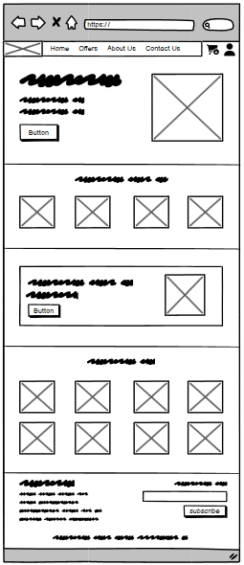

Figure 1 - Home

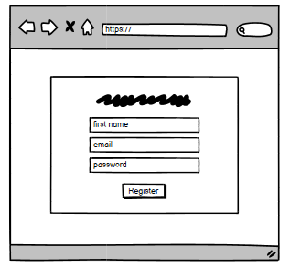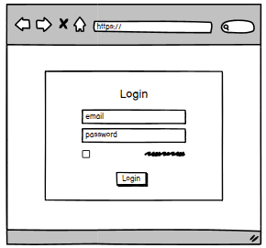

Figure 2- Register

Figure 3- Login

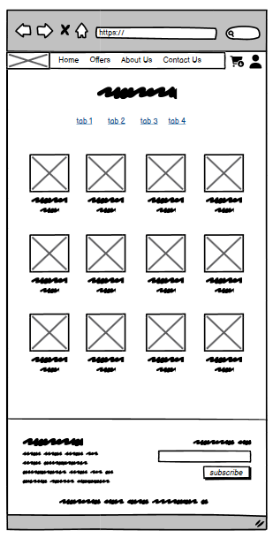

Figure 4- Store

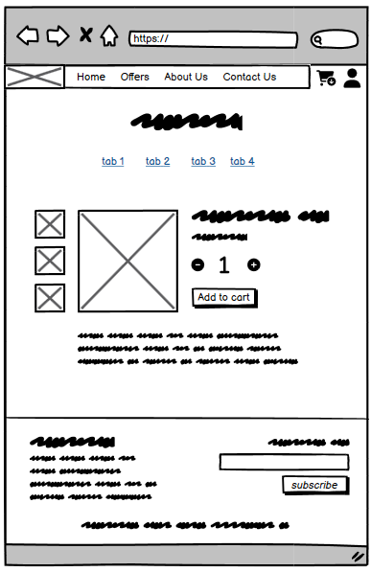

Figure 5- Product

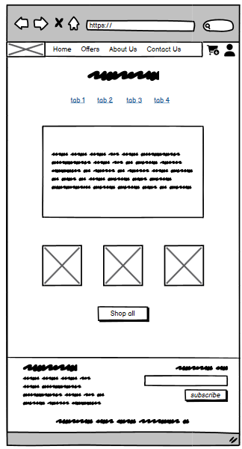

Figure 6- Blog

### **3.1.2 Wireframes- Android**

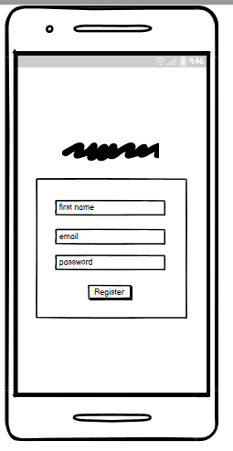

Figure 7- Register

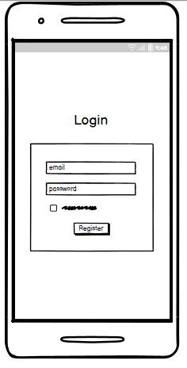

Figure 8- Login

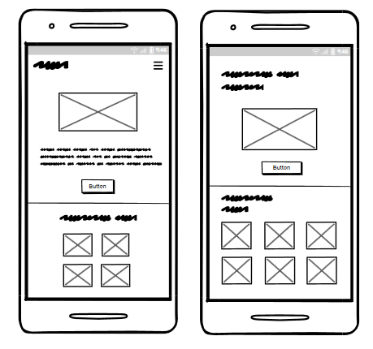

Figure 9- Home

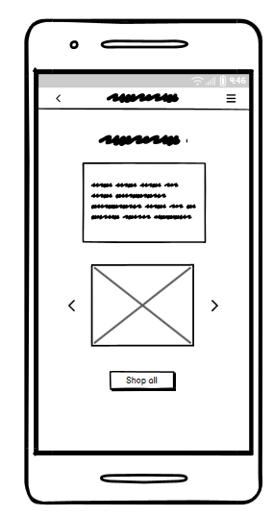

Figure 10- Blog

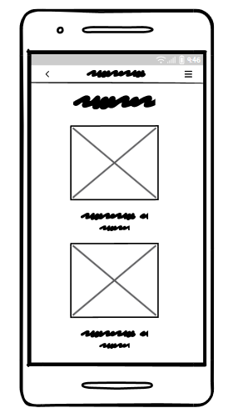

Figure 11- Store

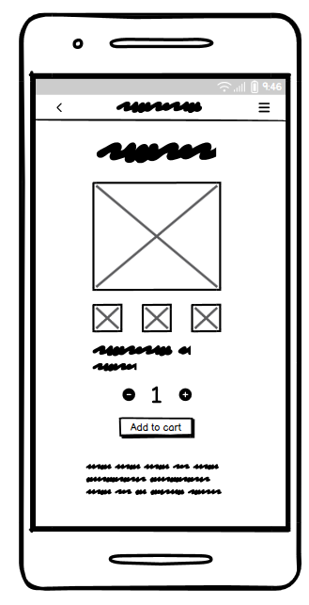

Figure 12- Product

### **3.1.3 Mockup – Web**

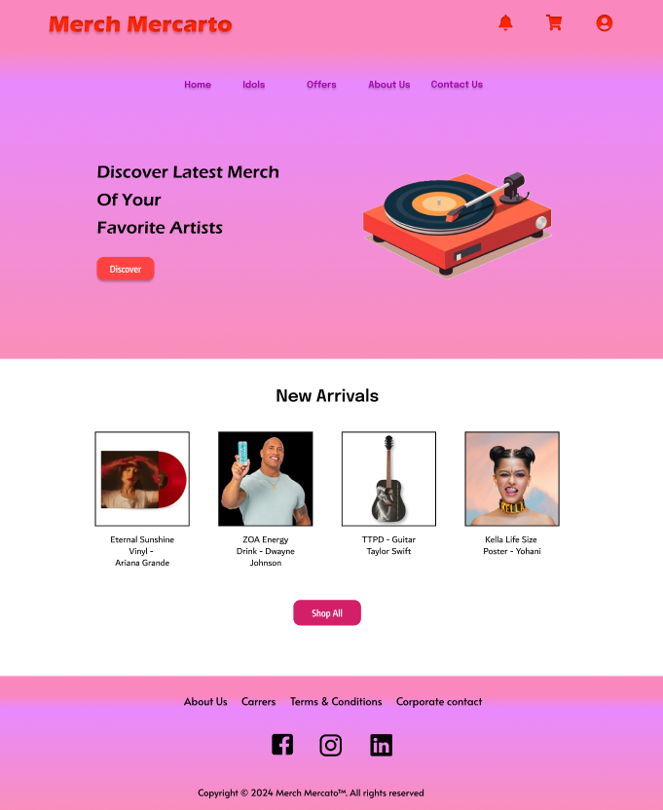

Figure 13- Home

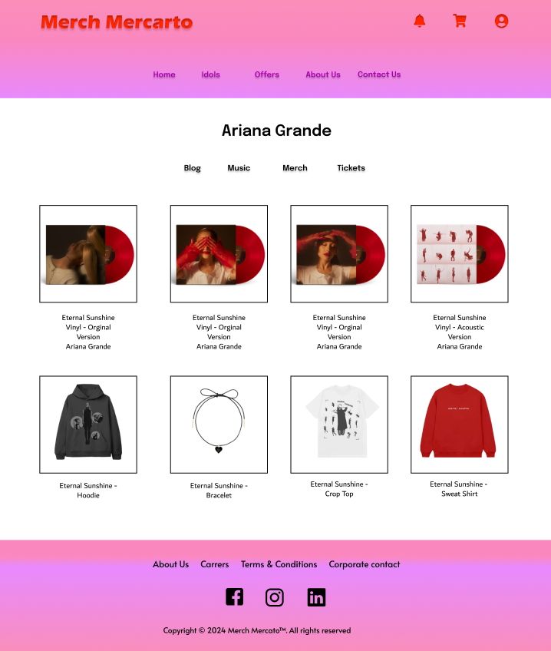

Figure 14- Store

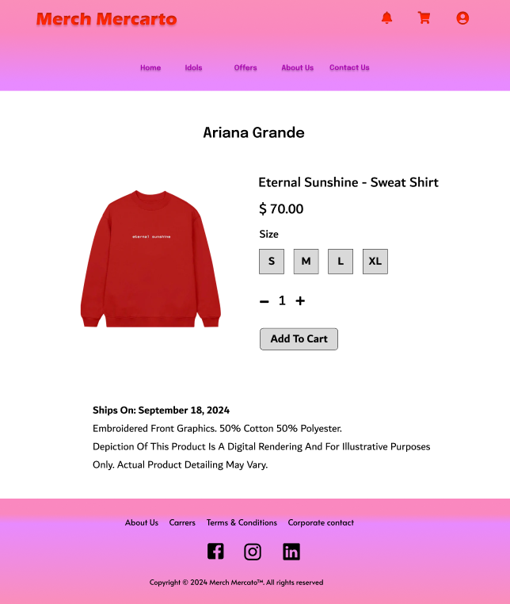

Figure 15- Product

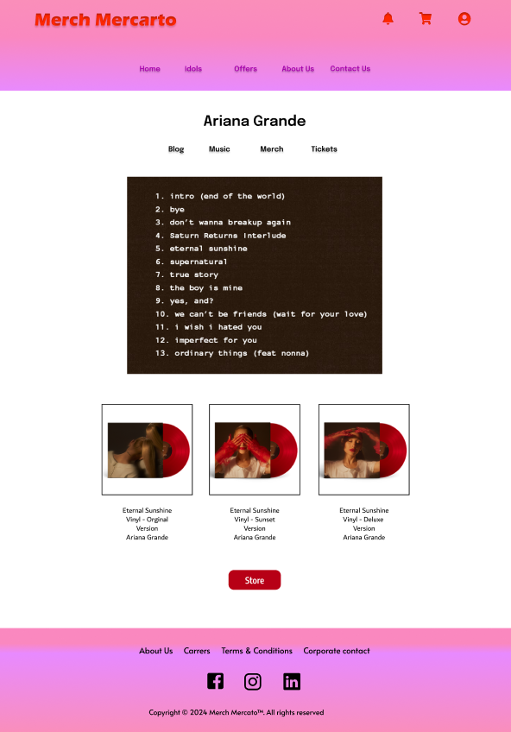

Figure 16- Blog

### **3.1.3 Mockup – Android**

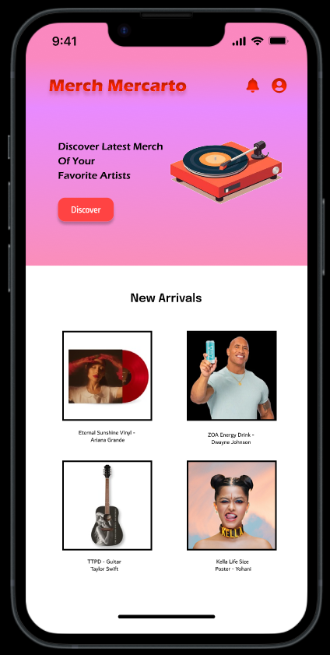

Figure 17- Home

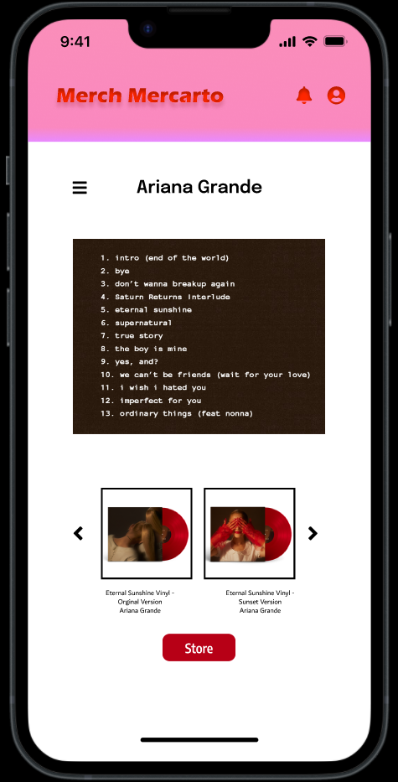

Figure 18- Blog

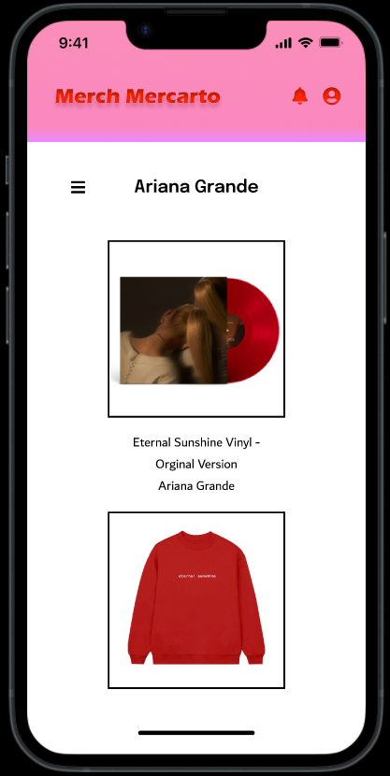

Figure 19- Store

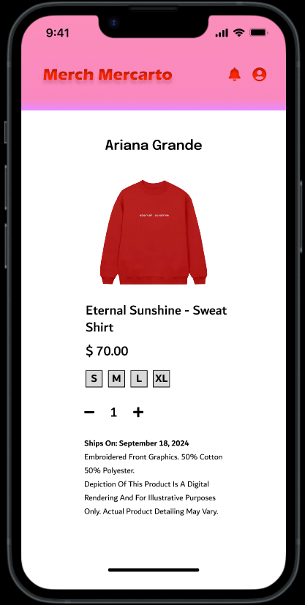

Figure 20- Product

## **3.2 ER Diagram**

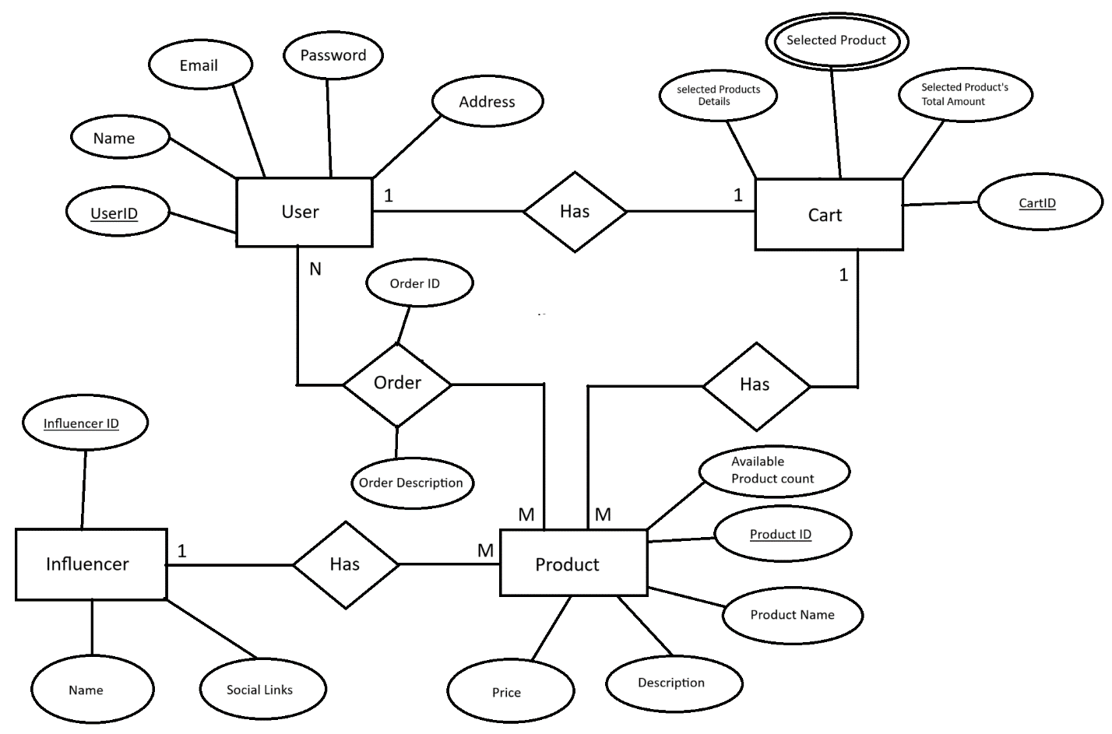

## **3.3 UML Diagram**

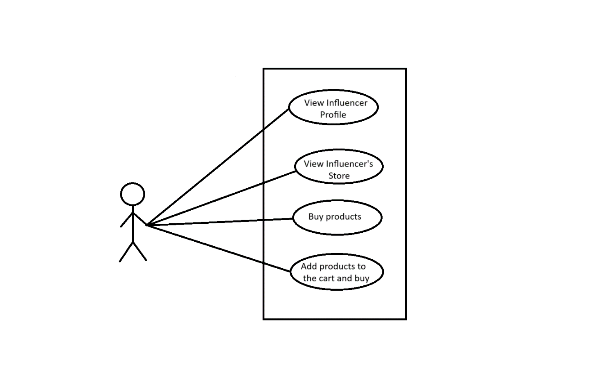

## **3.4 Class Diagram**

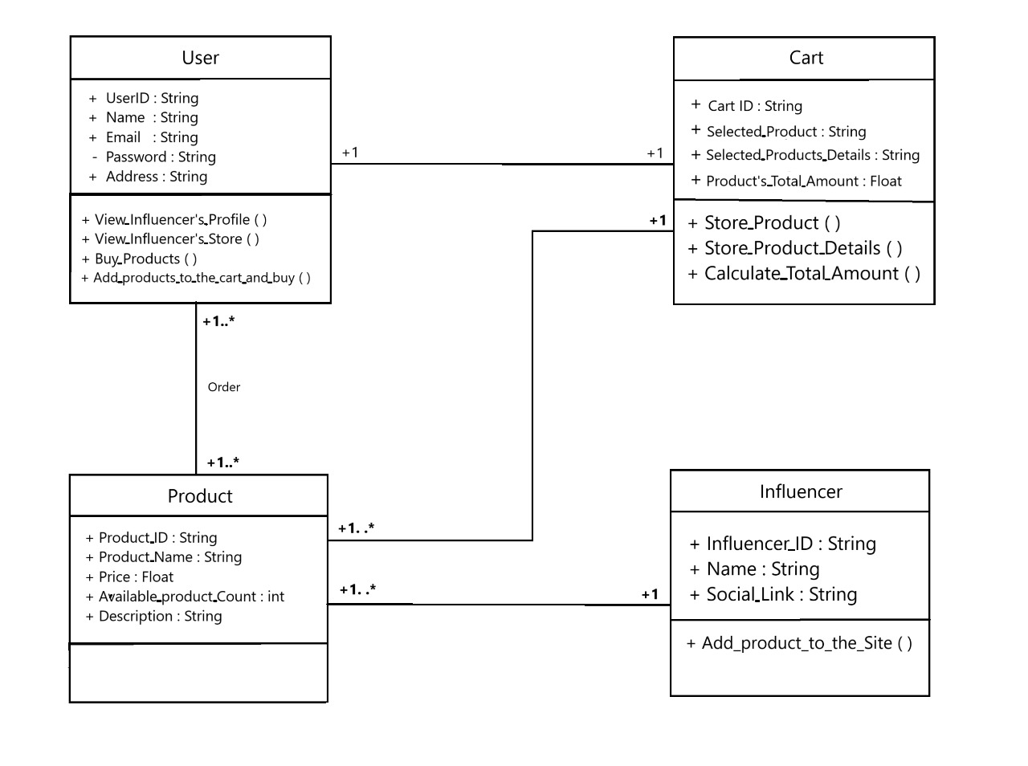

# **Chapter 04: References**